**Experiment No. 3a**

**Title :** Implementation of Factorial using recursion

**Problem Statement :** Write a C code to find factorial of a number using recursion

**Algorithm :**

**Step 1:** Start

**Step 2:** Declare a function called fact() which takes integer number as argument and calls itself with number multiplied with decremented version of the number till it becomes 1

**Step 3:** Input number whose factorial has to be found

**Step 4:** call fact() on the number inputted

**Step 5:** Display the result

**Step 6:** Stop

**Program :**

#include<iostream>

using namespace std;

int fact(int n) //recursive factorial function

{

if(n == 1)//exit condition of function

{

return(1);

}

else

return(n*fact(n-1));//recursive call of the function

}

int main()

{

cout<<"**** F A C T O R I A L *****\n";

int n,ans;

cout<<"Enter the number : ";

cin>>n;//input the number whose factorial has to be found

ans = fact(n);//call factorial function on that number

cout<<"The factorial of "<<n<<" is : "<<ans<<endl;//Display the result

}

**Output :**

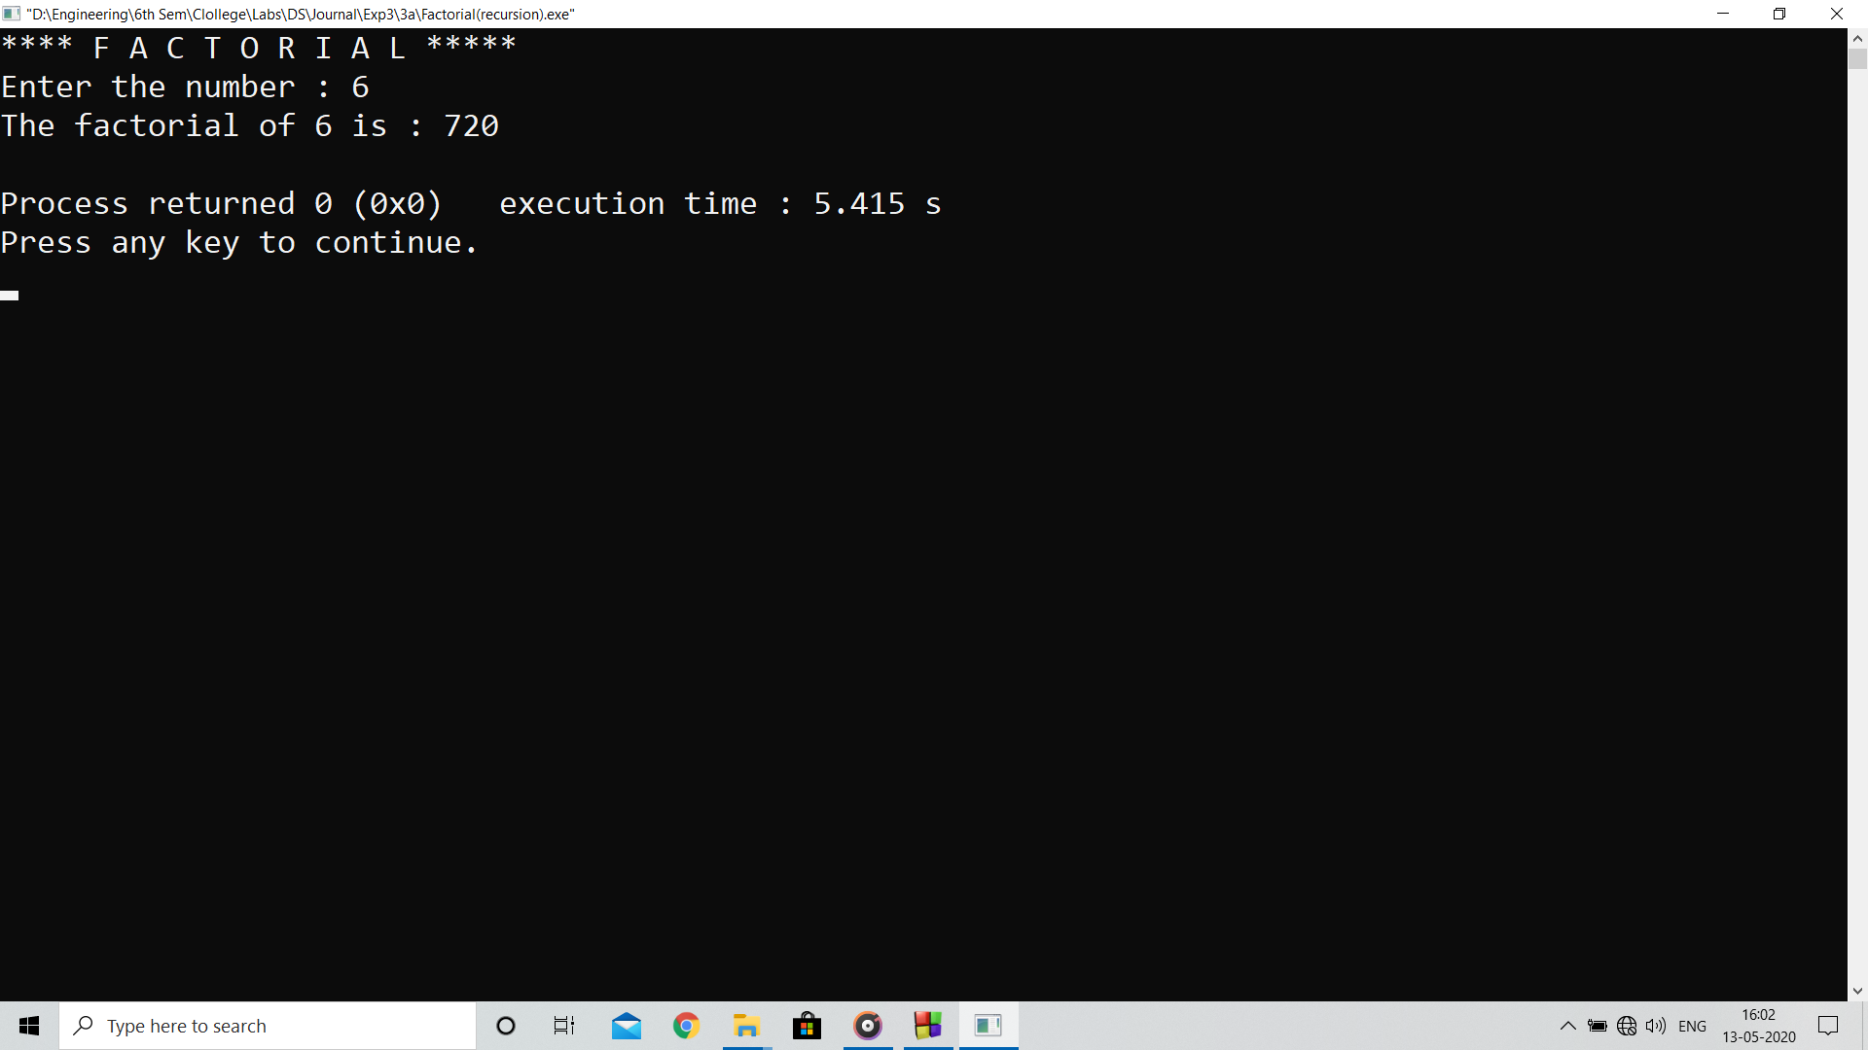

**Analysis:**

Program computes factorial using recursive calls which is more expensive process compared to for loops as the control flow remains in the same context in for loops.

**Limitation :**

Cannot compute the factorial of larger number as restricted by integer data type.